HTML:
Problem statement-1 : Create your resume page as per the format shown in the figure on LHS.

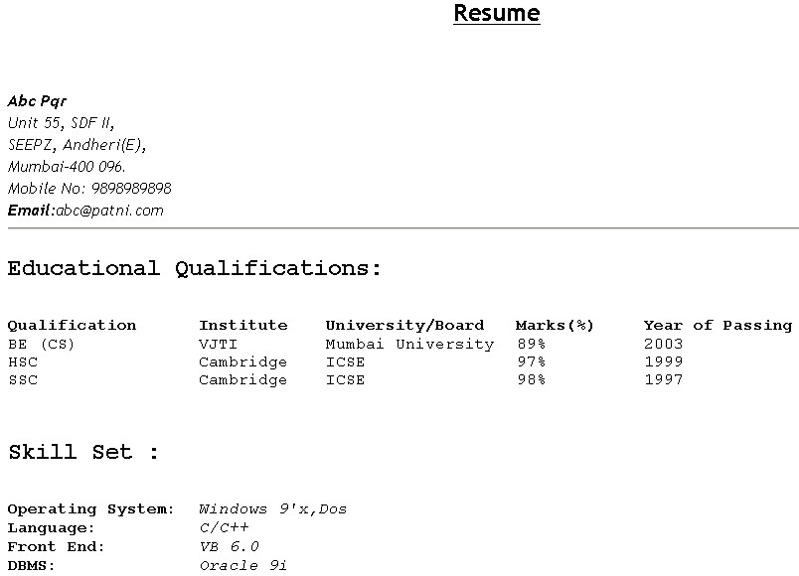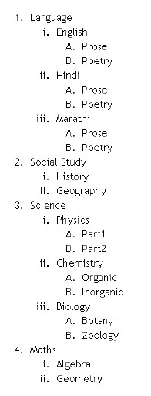
Problem statement
-
2
:
Create a web page to display a list as shown in the figure on RHS:

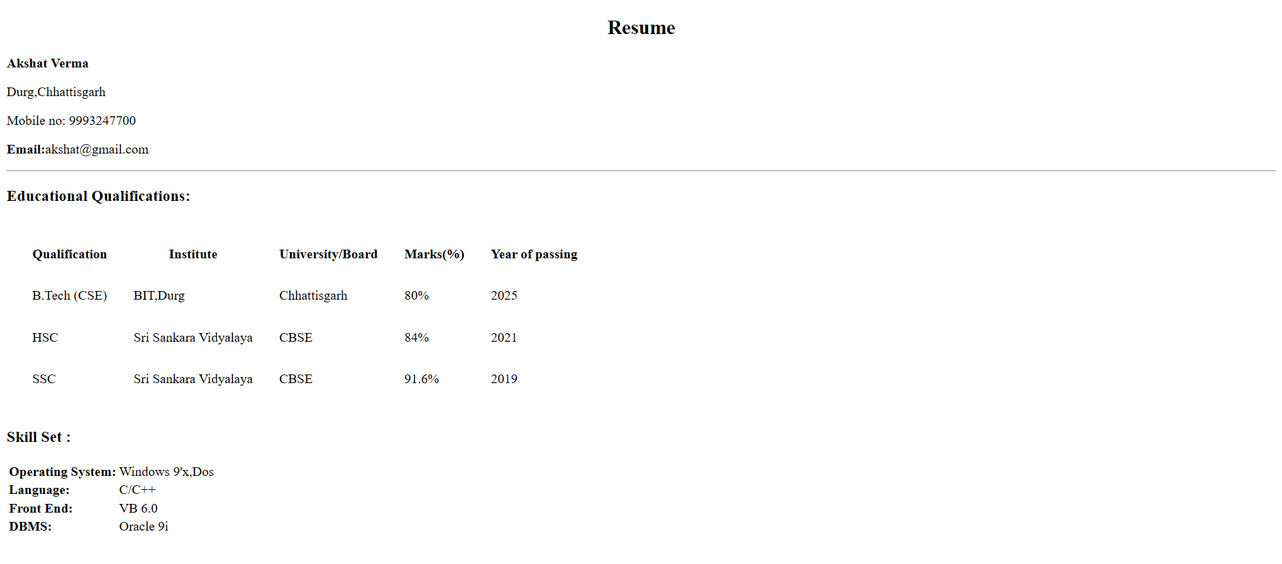
<!DOCTYPE html>
<html lang="en">
<head>
<meta charset="UTF-8">
<meta name="viewport" content="width=device-width, initial-scale=1.0">
<title>Resume</title>
</head>
<body>
<h2 style="text-align: center;">Resume</h2>

<div>
<p><b>Akshat Verma</b></p>
<p>Durg,Chhattisgarh</p>
<p>Mobile no: 9993247700</p>
<p><b>Email:</b>akshat@gmail.com</p>
<hr>
</div>
<div>
<h3>Educational Qualifications:</h3>
<table cellspacing="30px">
<tr>
<th>Qualification</th>
<th>Institute</th>
<th>University/Board</th>
<th>Marks(%)</th>
<th>Year of passing</th>
</tr>
<tr>
<td>B.Tech (CSE)</td>
<td>BIT,Durg</td>
<td>Chhattisgarh</td>
<td>80%</td>
<td>2025</td>
</tr>
<tr>
<td>HSC</td>
<td>Sri Sankara Vidyalaya</td>
<td>CBSE</td>
<td>84%</td>
<td>2021</td>
</tr>
<tr>
<td>SSC</td>
<td>Sri Sankara Vidyalaya</td>
<td>CBSE</td>
<td>91.6%</td>
<td>2019</td>
</tr>
</table>
</div>

<div>
<h3><b>Skill Set :</b></h3>
<table>
<tr>
<td><b>Operating System:</b></td>
<td>Windows 9'x,Dos</td>
</tr>
<tr>
<td><b>Language:</b></td>
<td>C/C++</td>
</tr>
<tr>
<td><b>Front End:</b></td>
<td>VB 6.0</td>
</tr>
<tr>
<td><b>DBMS:</b></td>
<td>Oracle 9i</td>
</tr>
</table>
</div>
</body>
</html>

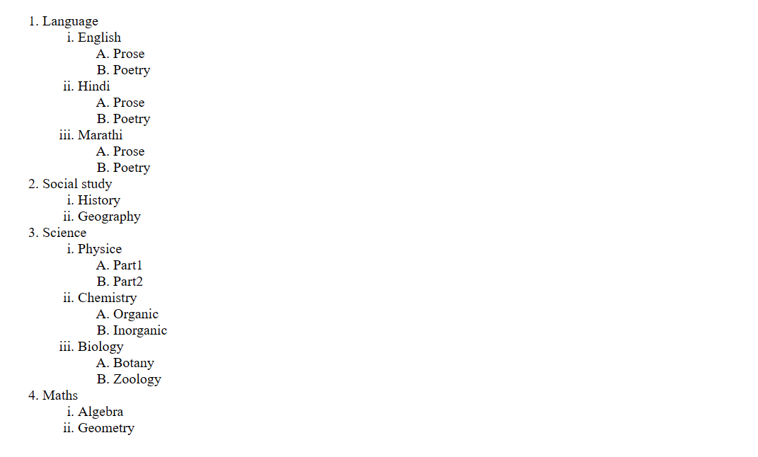
<!DOCTYPE html>
<html lang="en">
<head>
<meta charset="UTF-8" />
<meta name="viewport" content="width=device-width, initial-scale=1.0" />
<title>List</title>
</head>
<body>
<ol>
<li>Language</li>
<ol type = i>
<li>English</li>
<ol type = A>
<li>Prose</li>
<li>Poetry</li>
</ol>
<li>Hindi</li>
<ol type = A>
<li>Prose</li>
<li>Poetry</li>
</ol>
<li>Marathi</li>
<ol type = A>
<li>Prose</li>
<li>Poetry</li>
</ol>
</ol>
<li>Social study</li>
<ol type = i>
<li>History</li>
<li>Geography</li>
</ol>
<li>Science</li>
<ol type="i">
<li>Physice</li>
<ol type = A>
<li>Part1</li>
<li>Part2</li>
</ol>
<li>Chemistry</li>
<ol type = A>
<li>Organic</li>
<li>Inorganic</li>
</ol>
<li>Biology</li>
<ol type = A>
<li>Botany</li>
<li>Zoology</li>
</ol>

</ol>
<li>Maths</li>
<ol type = i>
<li>Algebra</li>
<li>Geometry</li>
</ol>
</body>
</html>

Problem statement-3-a : Create a web page to display tables as shown in the figures below. Clicking on link should lead the user to another document that displays a brief description of the book and review comments.

<!DOCTYPE html>
<html lang="en">
<head>
<meta charset="UTF-8" />
<meta name="viewport" content="width=device-width, initial-scale=1.0" />
<title>Table</title>
</head>
<body style="margin: 50px 100px;">
<h1>List of Java Books</h1>
<table border= cellspacing="20px">
<tr>
<th>Book Title</th>
<th>Author</th>
<th>Book Price</th>
</tr>
<tr>
<td><a href="/">Core JAVA</a> </td>
<td>Cay Horstman</td>
<td>400</td>
</tr>

<tr>
<td><a href="/">Begining Java</a></td>
<td>Ivar Horton</td>
<td>600</td>
</tr>

<tr>
<td><a href="/">Learning Java</a></td>
<td>Kishori Shahane</td>
<td>400</td>
</tr>

<tr>
<td><a href="/">Java Cookbook</a></td>
<td>John Keller</td>
<td>800</td>
</tr>
</table>
</body>
</html>

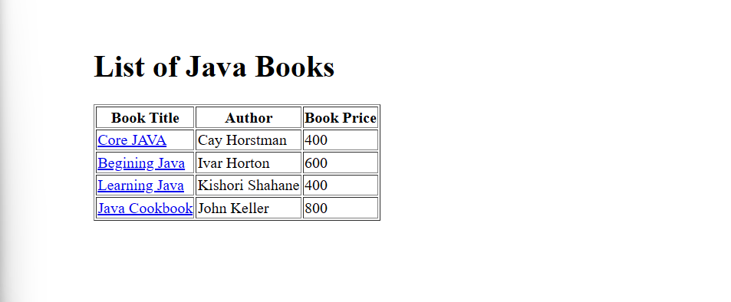
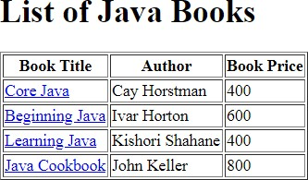

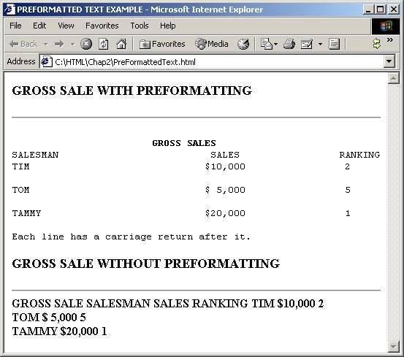

Q3b Design following page

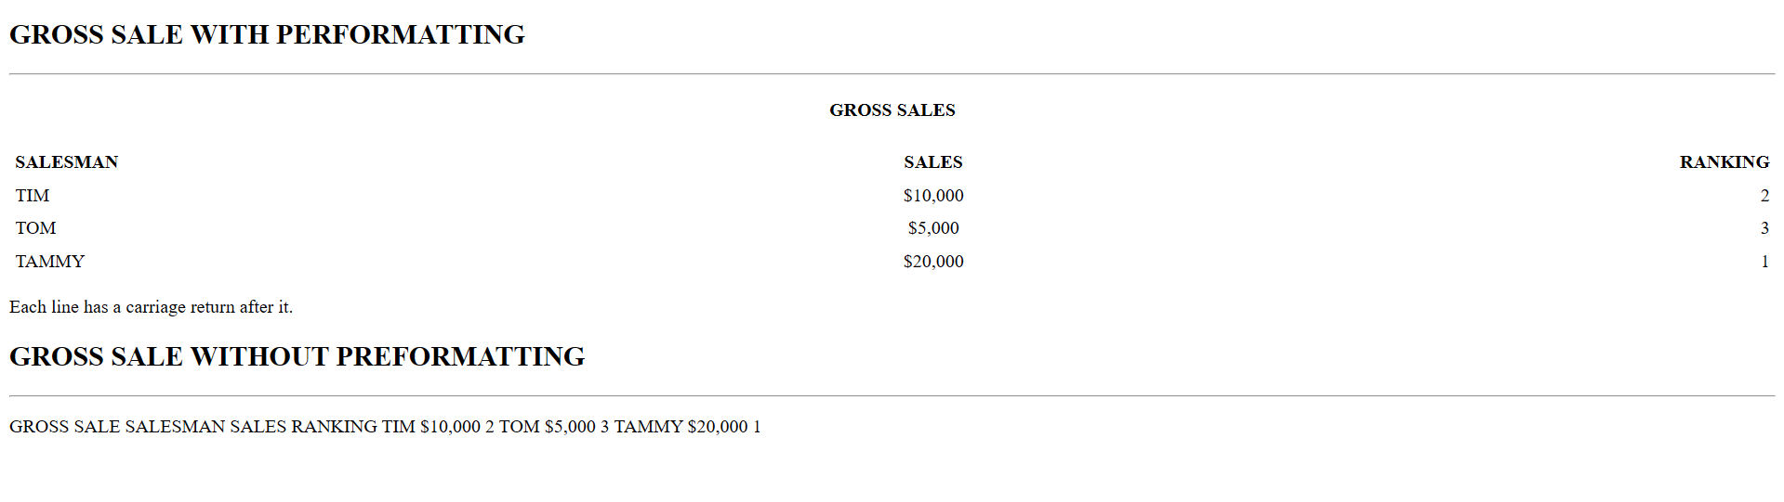
<!DOCTYPE html>
<html lang="en">
<head>
<meta charset="UTF-8" />
<meta name="viewport" content="width=device-width, initial-scale=1.0" />
<title>Document</title>
</head>
<body>
<h2>GROSS SALE WITH PERFORMATTING</h2>
<hr />
<h4 style="text-align: center">GROSS SALES</h4>
<table border="0" cellpadding="5" cellspacing="0" style="
width: 100%;">
<tr>
<th style="text-align: left">SALESMAN</th>
<th style="text-align: center">SALES</th>
<th style="text-align: right">RANKING</th>
</tr>
<tr>
<td style="text-align: left">TIM</td>
<td style="text-align: center">$10,000</td>
<td style="text-align: right">2</td>
</tr>
<tr>
<td style="text-align: left">TOM</td>
<td style="text-align: center">$5,000</td>
<td style="text-align: right">3</td>
</tr>
<tr>
<td style="text-align: left">TAMMY</td>
<td style="text-align: center">$20,000</td>
<td style="text-align: right">1</td>
</tr>
</table>

<p>Each line has a carriage return after it.</p>

<h2>GROSS SALE WITHOUT PREFORMATTING</h2>
<hr>
<p>
GROSS SALE SALESMAN SALES RANKING TIM $10,000 2 TOM $5,000 3 TAMMY $20,000
1
</p>
</body>
</html>

Q3 cDesign a web page to display a calendar for a month using html table.
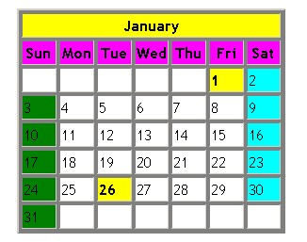

<!DOCTYPE html>
<html lang="en">
<head>
<meta charset="UTF-8">
<meta name="viewport" content="width=device-width, initial-scale=1.0">
<title>Document</title>

<style>
th{
width: 50px;
}
#monthno{
background-color: rgb(250, 250, 93);
}
#weekno{
background-color: rgb(242, 106, 252);
}
</style>
</head>
<body>
<table border="1" style="margin: 20px;">
<tr id="monthno"><th colspan="7" >January</th></tr>
<tr id="weekno">
<th>Sun</th>
<th>Mon</th>
<th>Tue</th>
<th>Wed</th>
<th>Thu</th>
<th>Fri</th>
<th>Sat</th>
</tr>
<tr>
<td></td>
<td></td>
<td></td>
<td></td>
<td></td>
<td style="background-color: yellow;">1</td>
<td style="background-color: cyan;">2</td>
</tr>
<tr>
<td style="background-color: green;">3</td>
<td>4</td>
<td>5</td>
<td>6</td>
<td>7</td>
<td>8</td>
<td style="background-color: cyan;">9</td>
</tr>
<tr>
<td style="background-color: green;">10</td>
<td>11</td>
<td>12</td>
<td>13</td>
<td>14</td>
<td>15</td>
<td style="background-color: cyan;">16</td>
</tr>
<tr>
<td style="background-color: green;">17</td>
<td>18</td>
<td>19</td>
<td>20</td>
<td>21</td>
<td>22</td>
<td style="background-color: cyan;">23</td>
</tr>
<tr>
<td style="background-color: green;">24</td>
<td>25</td>
<td style="background-color: yellow;">26</td>
<td>27</td>
<td>28</td>
<td>29</td>
<td style="background-color: cyan;">30</td>
</tr>
<tr>
<td style="background-color: green;">31</td>
<td></td>
<td></td>
<td></td>
<td></td>
<td></td>
<td></td>
</tr>
</table>
</body>
</html>
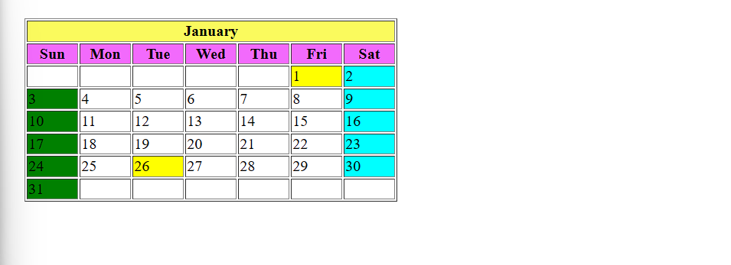

Design a simple home page for a company to display employee details as given below.

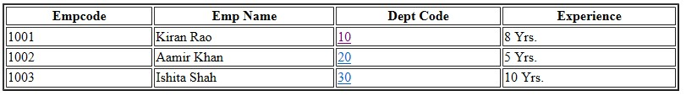
Figure 1: EmployeeDetails

When you click the department code “10” hyperlink, page with following content should be displayed.

This is Sales department located at Mumbai...

Figure 2: Sales Department

When you click the department code “20” hyperlink, page with following content should be displayed.

This is training department located at Pune...

Figure 3: Training Department

When you click the department code “30” hyperlink, page with following content should be displayed.

This is accounts department located at Chennai...

<!DOCTYPE html>
<html lang="en">
<head>
<meta charset="UTF-8">
<meta name="viewport" content="width=device-width, initial-scale=1.0">
<title>Page Linking</title>
<style>
th{
width: 200px;
}
</style>
</head>
<body>
<table border="1px">
<tr>
<th>EmpCode</th>
<th>Emp Name</th>
<th>Dept Code</th>
<th>Experience</th>
</tr>
<tr>
<td>1001</td>
<td>Kiran Rao</td>
<td><a href="dept10.html">10</a></td>
<td>8 Yrs.</td>
</tr>

<tr>
<td>1002</td>
<td>Aamir Khan</td>
<td><a href="dept20.html">20</a></td>
<td>5 Yrs.</td>
</tr>

<tr>
<td>1003</td>
<td>Ishita Shah</td>
<td><a href="dept30.html">30</a></td>
<td>10 Yrs.</td>
</tr>
</table>
</body>
</html>

Dept10.html
<!DOCTYPE html>
<html lang="en">
<head>
<meta charset="UTF-8">
<meta name="viewport" content="width=device-width, initial-scale=1.0">
<title>dept 10</title>
</head>
<body>
<table>
<tr><td>This is sales department located at Mumbai...</td></tr>
</table>
</body>
</html>

Dept20.html
<!DOCTYPE html>
<html lang="en">
<head>
<meta charset="UTF-8">
<meta name="viewport" content="width=device-width, initial-scale=1.0">
<title>dept 20</title>
</head>
<body>
<table>
<tr><th>This is sales department located at Pune...</th></tr>
</table>
</body>
</html>

Dept30.html
<!DOCTYPE html>
<html lang="en">
<head>
<meta charset="UTF-8">
<meta name="viewport" content="width=device-width, initial-scale=1.0">
<title>dept 30</title>
</head>
<body>
<table>
<tr><th>This is sales department located at Chennai...</th></tr>
</table>
</body>
</html>
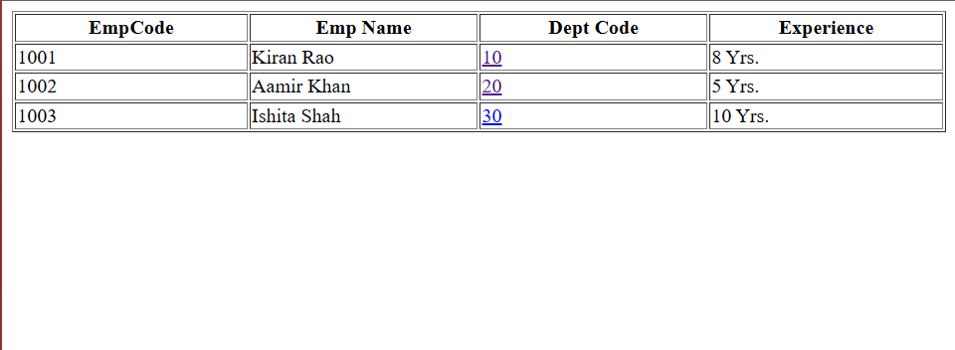

Dept10.html page
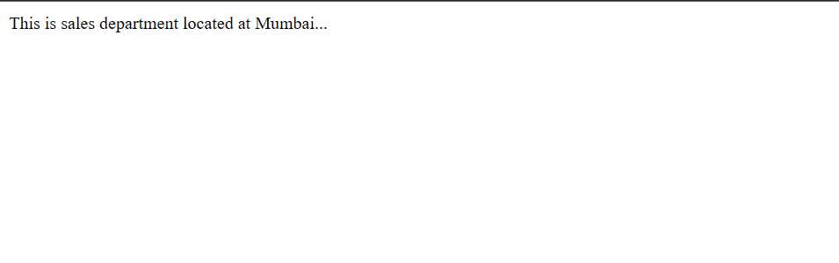

Dept20.html page
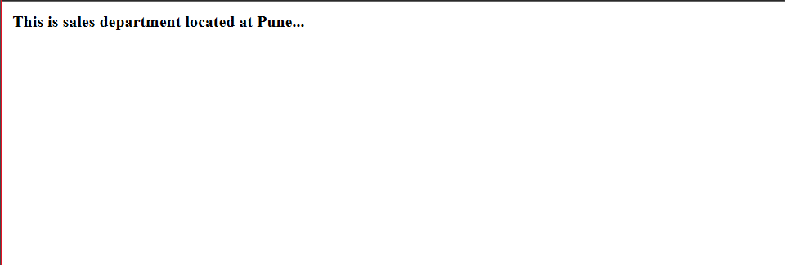

Dept30.html page
